MATHEMATICS METHODS

MAWA Semester 1 (Unit 3) Examination 2018
Calculator-free

Marking Key

© MAWA, 2018
Licence Agreement
This examination is Copyright but may be freely used within the school that purchases this licence.
- The items that are contained in this examination are to be used solely in the school for which they are purchased.
- They are not to be shared in any manner with a school which has not purchased their own licence.
- The items and the solutions/marking keys are to be kept confidentially and not copied or made available to anyone who is not a teacher at the school. Teachers may give feedback to students in the form of showing them how the work is marked but students are not to retain a copy of the paper or marking guide until the agreed release date stipulated in the purchasing agreement/licence.

The release date for this exam and marking scheme is
- the end of week 8 of term 2, 2018

Section One: Calculator-free (50 Marks)

Question 1 (a) (2 marks)
Solution
.
Mathematical behaviours | Marks
- applies product rule  - differentiates term | 1  1

Question 1 (b) (2 marks)
Solution
Mathematical behaviours | Marks
- applies the chain rule  - differentiates sin x term | 1  1

Question 1 (c) (3 marks)
Solution
Mathematical behaviours | Marks
- applies chain rule to obtain  - applies quotient rule  - correct answer | 1  1  1

Solution
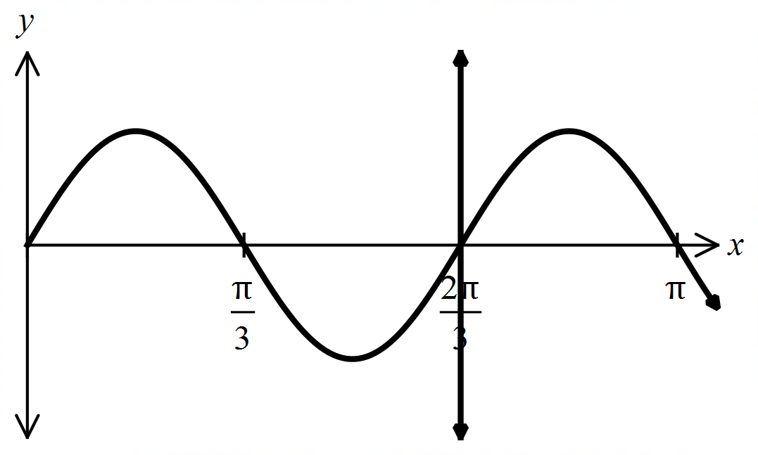
Mathematical behaviours | Marks
- states a correct expression using integrals to determine the area  - anti-differentiates integral correctly  - subs in limits of integration correctly  - determines correct result | 1  1  1  1
Question 2 (4 marks)

Question 3 (3 marks)
Solution
Mathematical behaviours | Marks
- anti-differentiates square root term  - uses anti-derivative and to determine  - states | 1  1  1

Question 4 (a) (1 mark)
Solution
$X$ has a discrete uniform distribution
Mathematical behaviours | Marks
- states that the distribution is uniform | 1

Question 4 (b) (1 mark)
Solution
There are $550-250+1=301$ whole numbers in the interval $250≤X≤550.$
So $P\left(250≤X≤550\right)=0.301$
Mathematical behaviours | Marks
- correct answer | 1

Question 4 (c) (2 marks)
Solution
There are $\frac{1000}{7}=142\frac{6}{7},$ and so there are $142$ whole numbers in the interval $1≤X≤1000$ that are divisible by $7.$
So $P(X \text{is divisible by 7) = 0.142}$.
Mathematical behaviours | Marks
- obtains 142 whole numbers divisible by 7  - divides by 1000 | 1  1

Question 4 (d) (4 marks)
Solution
In the interval $1≤X≤1000$there are:
$100$ whole numbers that are divisible by $10,$ $40$ whole numbers that are divisible by $25,$ and $20$ whole numbers that are divisible by both $10 \text{and }25,$(i.e. divisible by $50)$
So there are $100+40-20=120$ whole numbers that are divisible by $10 \text{or }25$ .
and so $P(X \text{is divisible by 10 or }25\text{) = 0.12}$.
Mathematical behaviours | Marks
- correct numbers for divisibility by 10 and by 25  - uses $\#(A∪B)=\#\left(A\right)+\#\left(B\right)-\#(A∩B)$  - divides by 1000 | 1+1  1  1

Question 4 (e) (2 marks)
Solution
The following numbers have exactly two 3’s in their decimal expansion:
$33, 133, 233,433, …,933$, $303,313,323,343, …,393$, and $330,331,332,334, …339$
So $P(X \text{has exactly two 3's in its decimal expansion)}=\frac{27}{1000}=0.027$.
Mathematical behaviours | Marks
- obtains 27 whole numbers with the desired property  - divides by 1000 | 1  1

Question 5 (3 marks)
Solution
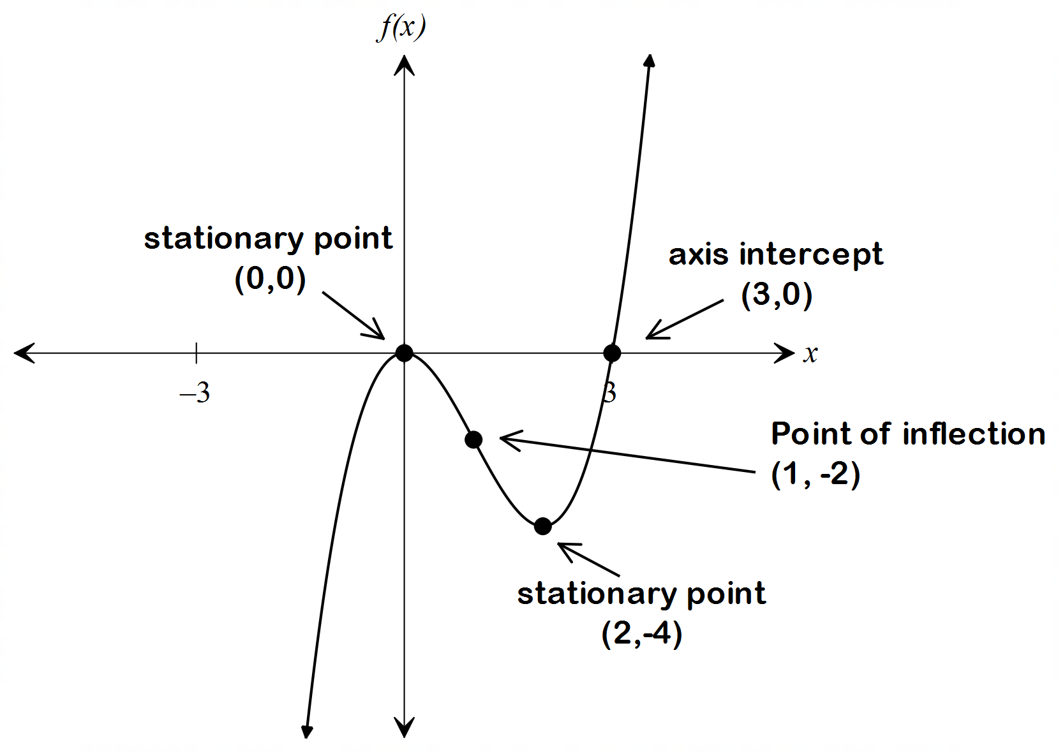

Mathematical behaviours | Marks
- correctly identifies stationary points  - correctly identifies point of inflection  - accurate sketch of the curve including x axis intercepts | 1  1  1

Solution
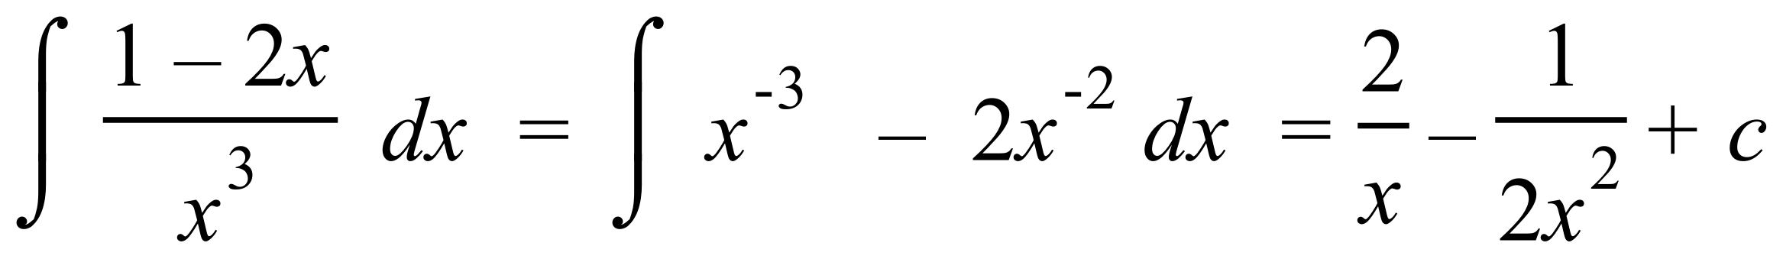
Mathematical behaviours | Marks
- splits the fraction into two parts and anti-differentiates  - states anti-derivative including +c | 1  1
Question 6 (a) (2 marks)

Solution
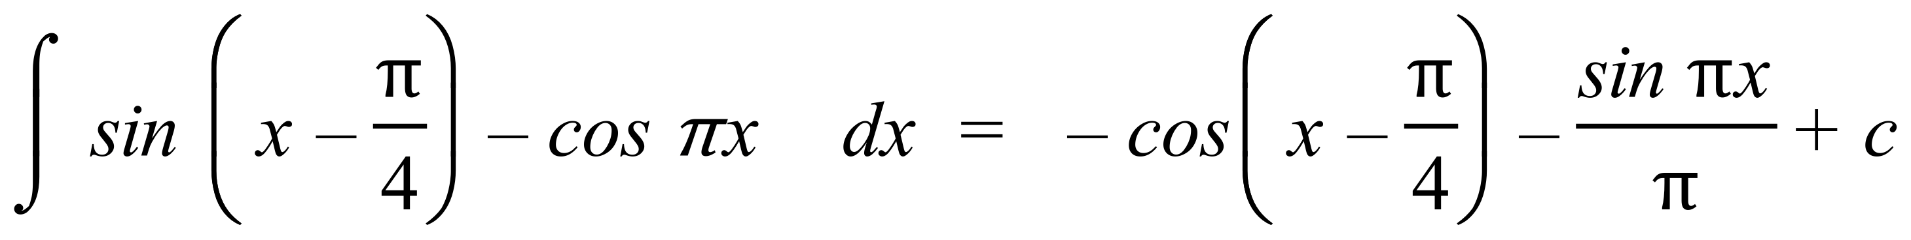
Mathematical behaviours | Marks
- anti-differentiates sin or cos part of expression correctly  - states correct solution | 1  1
Question 6 (b) (2 marks)

Solution
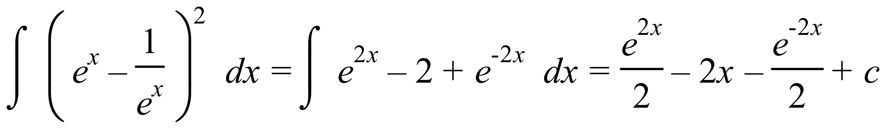
Mathematical behaviours | Marks
- expands brackets correctly  - anti-differentiates each part correctly | 1  1
Question 6 (c) (2 marks)

Solution
Mathematical behaviours | Marks
- correctly differentiates $\sec{x}$  - applies chain rule  - correct answer | 1  1  1
Question 7 (a) (3 marks)

Question 7 (b) (4 marks)
Solution
, when
Mathematical behaviours | Marks
- correct substitution and subtraction of fractions  - both exact values correct  - correct simplified answer | 1+1  1  1

Question 8 (a) (i) (1 mark)
Solution
Mathematical behaviours | Marks
- determines expression | 1

Question 8 (a) (ii) (3 marks)
Solution
Mathematical behaviours | Marks
- uses linearity to deduce  - uses relationship  - sums expressions and simplifies | 1  1  1

Question 8 (b) (2 marks)
Solution
Mathematical behaviours | Marks
- applies the Fundamental Theorem  - evaluates result | 1  1

Solution
Mathematical behaviours | Marks
- states m = 0 or m = 3  - states all correct values for m | 1  1
Question 8 (c) (i) (2 marks)

Question 8 (c) (ii) (2 marks)
Solution
Mathematical behaviours | Marks
- uses linearity to split  - evaluates sum of integrals | 1  1

